Final Assessment-Alternative Assessment
Semester | 202520 | Division | CIS
Assessment title in Syllabus | Final_Project_Portfolio | Program | Bachelor of Information Technology/ Bachelor of Information Systems
Course Code | CDS 2413
Course Title | INTRODUCTION TO DATA SCIENCE
Course Instructor |  | CRN
Assessment | Project Deliverable 1 – Data Analysis Report | Submission Date | Week 6
Student Declaration:
Academic Integrity Statement
In accordance with the HCT Academic Integrity Policy
• Students are required to refrain from all forms of academic integrity breaches as defined and explained by HCT.
• A student found guilty of having committed acts of academic integrity breach(es) will be subject to the relevant sanctions as outlined by HCT.
إفادة النزاهة الأكاديمية
وفقًا لسياسة كليات التقنية العليا للنزاهة الأكاديمية
• على الطلبة الإلتزام بلوائح وقواعد النزاهة الأكاديمية، كما هو مبيّن وموضح في السياسات والإجراءات الخاصة بكليات التقنية العليا.
• في حالة ارتكاب الطالب أي شكل من أشكال الإخلال بالنزاهة الأكاديمية، سيتعرض الى العقوبات الموضحة في السياسات ذات الصلة.
This assignment is entirely my/our own work except where I have duly acknowledged other sources in the text and listed those sources at the end of the assignment. I have not previously submitted this work to the HCT, or any other entity. I understand that I may be orally examined on my submission.

Student HCT ID(s): | H00595473 | H00532971 | H00 | H00
Student Name(s): | Amna Yousef Alsuwaidi | Salama Humaid Alamri
Student Signature
Chatbot (e.g. ChatGPT) statement
This submission allows you to use AI generated tools, but the prompt used must be stated and the response must be in red font. Include References to ChatGPT.

Instructions

Remove instructions and hints from the template before submitting the final report to BBLearn.

CLO1: Introduction and Data Wrangling (5 Points)

Purpose of Data Analysis (1 point)
<< Define the purpose of data analysis for the chosen dataset >>.

Data analysis is a process of examining, cleaning , interpreting data to find patterns, obtain valuable insights, and assist in making well-informed decisions.It enables in turning unstructured data into meaningful knowledge by identifying connections, patterns, and significant discoveries that can direct organizing, predicting, and problem-solving.

The purpose of Data analysis for our Dataset:

- To fully understand all the variables that affect the cost of health insurance.
- To find patterns and connections among factors like age, BMI, gender, number of children, smoking status, and region.
- To identify which variable strongly impacts the cost of insurance.
- To determine the differences in charges and compare various groups (such as smokers and non-smokers).
- To support in making data-driven decisions about risk assessment, pricing, and policy development.
- To create a prediction model capable of accurately determining future insurance costs.

Type of Programming (1 point)
<< Identify and Justify the type of programming used for data analysis.>>

Programming has become essential for data analysis since current datasets are frequently big, complicated, and challenging to handle by hand.We can accurately and efficiently process, analyze, and interpret data by using the help of programming.

Python is the computer language utilized for this data analysis, specifically for statistical computation and data analysis. Python is frequently used in data analysis because it offers reliable libraries like Matplotlib or Seaborn for data visualization, NumPy for numerical computations, and Pandas for managing and organizing datasets. These technologies enhance data cleaning, pattern detection, statistical analysis, and effective result presentation.

Python is a proper computer language method for our project because it is effective, simple to comprehend, and often used in data research. It enables us to thoroughly investigate the medical insurance dataset and determine the effects of various factors on insurance charges, such as age, BMI, and smoking status.

Type and Purpose of ML algorithm (1 point)
<< Identify the type and purpose of the machine learning algorithm to be implemented for the chosen dataset >>

A supervised learning algorithm, which is a regression algorithm, is the type of machine learning method that will be used for our medical insurance dataset.

The problem is regarded as a regression problem rather than a classification problem since the objective variable in this dataset is insurance charges, which is a continuous numerical number. The model is trained using labeled data in supervised learning, which means that a known output (insurance charges) is predicted using the input variables (age, BMI, smoking status, number of children, and region).

The Linear Regression algorithm, which models the connection between independent variables and a continuous dependent variable, would be the most suitable algorithm for the dataset. The goal of applying this regression algorithm is to:

- Predict health insurance costs based on individual characteristics.

- Determine which variables most significantly affect the cost of insurance.

- Calculate the correlation between variables (e.g., smoking affects charges).

- Encourage the use of data to inform pricing and risk assessment decisions.

We can create a predictive model that accurately predicts insurance charges while aiding in our understanding of the impact of various factors on total medical expenses by putting into practice a regression-based supervised learning algorithm.

Identify the Varaibles (1 point)
<< Identify and Justify the independent and dependent variables for the chosen dataset.>>

Based on their functions in the analysis and prediction model, the variables in the medical insurance dataset are separated into independent variables (input variables) and a dependent variable (output variables).

- Dependent variables are those that depend on independent factors and are what we want to predict or understand.

- The factors we change or identify to determine their impact on the dependent variable are known as independent variables. They serve as predictors that might impact the result.

The dependent variable is :

- Insurance charges
The outcome we aim to predict and examine is the insurance charges.Our projects main goal is to understand the variables that affect medical costs and develop a model that is able to determine them. The dependent variable is the cost of insurance charge , which is affected by variables such as age ,BMI,and smoking status.

The independent variables are :

- Age
- Gender
- BMI
- Number of children
- Smoking status
- Region

By serving as factors in the regression model, these factors help in the estimation and understanding of changes in the cost of insurance.

Sampling (1 point)
<< Will you do the sampling? Identify and Justify the type of sampling to be used for the chosen dataset.>>

We are going to use sampling methods for our project.Sampling helps ensure that the results can be generalized without constantly using the complete dataset and also helps in the efficient testing of our model.

- Simple Random Sampling:

Simple random sampling gives each member of the dataset an equal chance of being selected. This method prevents bias during selection and ensures that the selection process is ethical. It is appropriate for our dataset since it allows us to get a representative sample without favoring any certain group.

- Systematic Random Sampling:
Every k-th observation from the dataset is selected, every fifth or tenth row is chosen for systematic sampling. This approach guarantees that the sample spreads equally throughout the dataset and is simple to use. When the data is already structured and arranged, it is effective and practical.

We chose systematic sampling and simple random sampling because they are both neutral, simple to use and appropriate for structured datasets such as our medical insurance data. While preserving analytical efficiency, these techniques aid in guaranteeing that the sample we have chosen accurately reflects the entire population.

CLO2: Descriptive, Exploratory and Statistical Analysis (10 Points)

Purpose of Descriptive Analysis (1 point)
<< Justify why you want to perform the descriptive analysis for the chosen dataset. >>.

The descriptive analysis is conducted to organize, understand, and summarize the fundamental characteristics of the dataset prior to implementing predictive modeling methods.

For the dataset that we have chosen, the Medical Insurance Predictor dataset, the descriptive analysis is important to achieve the following:

- To understand the distribution of medical insurance charges.
- To be able to identify the central tendency such as the mean and median, and the dispersion such as the variance and standard deviation.
- To identify possible outliers in the insurance charges.
- To assess the variability of the medical costs among individuals.
- To apply a statistical foundation before regression and classification modeling.
As the dependent variable, the charges, shows the continuous monetary values, the descriptive analysis helps us in determining if the data is normally distributed and suitable for parametric statistical testing

Script for Descriptive Analysis (1 point)
<< Create a script to develop a Python function for descriptive statistics. The input for the function should be the sample and the field to perform the descriptive statistics..>>

To make sure that our project is implementing reusability and structured analysis, we have developed a Python function to compute the descriptive statistics for any numeric field in a sample.

Python code:

import numpy as np
import pandas as pd
def descriptive_statistics(sample, field):
data = sample[field]

statistics = {
"Count": data.count(),
"Mean": data.mean(),
"Median": data.median(),
"Standard Deviation": data.std(),
"Variance": data.var(),
"Minimum": data.min(),
"Maximum": data.max(),
"Range": data.max() - data.min(),
"Q1": data.quantile(0.25),
"Q3": data.quantile(0.75)
}

return statistics

The purpose of developing a separate function is to implement modular programming, enhance code clarity, and to allow the repeated application of the same procedure throughout different sampling techniques.

The function will accept two parameters, which include:
- The dataset sample
- The selected field, which is the dependent variable.
This will return important statistical measures such as count, mean, median, standard deviation, variance, minimum, maximum, range, and quartiles

Random Sampling (1 point)
<< Create a program to random sampling of size 150 and find the descriptive statistics for the dependent variable from the sample [Apply the descriptive function which you created].>>

Measure of Central Tendency:

data = pd.read_csv('medical_insurance.csv')
# Generate a random sample of the data
sample_size = 150
ds = data.sample(n=sample_size, replace=False, random_state=42)
print(ds)

Output:
person_id age sex region urban_rural income education \
75721 48299 60 Male East Urban 30600.0 Masters
80184 81048 40 Male North Rural 55900.0 Some College
19864 92755 55 Male East Urban 226200.0 HS
76699 46008 40 Female Central Suburban 70700.0 Some College
92991 76982 70 Male West Urban 107200.0 No HS
... ... ... ... ... ... ... ...
93322 63213 69 Male South Suburban 59600.0 Some College
5324 58832 68 Male West Rural 25400.0 Doctorate
52925 78447 54 Male North Urban 39000.0 Bachelors
62864 1536 22 Female South Rural 223500.0 Some College
8018 57477 30 Female West Suburban 38300.0 Some College

marital_status employment_status household_size ... liver_disease \
75721 Single Employed 4 ... 0
80184 Married Employed 2 ... 0
19864 Married Employed 3 ... 0
76699 Married Employed 3 ... 0
92991 Single Employed 2 ... 0
... ... ... ... ... ...
93322 Married Unemployed 2 ... 0
5324 Divorced Retired 1 ... 0
52925 Married Retired 3 ... 0
62864 Married Retired 3 ... 0
8018 Single Employed 2 ... 0

arthritis mental_health proc_imaging_count proc_surgery_count \
75721 0 1 1 0
80184 0 0 0 0
19864 0 0 0 0
76699 1 0 1 0
92991 1 0 0 0
... ... ... ... ...
93322 0 0 1 0
5324 0 0 0 0
52925 0 0 0 0
62864 0 1 0 0
8018 0 0 1 0

proc_physio_count proc_consult_count proc_lab_count is_high_risk \
75721 1 0 1 1
80184 0 1 0 0
19864 1 0 0 1
76699 0 1 0 0
92991 0 1 1 1
... ... ... ... ...
93322 0 0 0 1
5324 0 1 1 0
52925 1 1 0 0
62864 0 0 1 0
8018 0 1 1 0

had_major_procedure
75721 1
80184 0
19864 0
76699 0
92991 0
... ...
93322 0
5324 0
52925 0
62864 0
8018 0

[150 rows x 54 columns]

ds.mean(numeric_only=True)

Output:

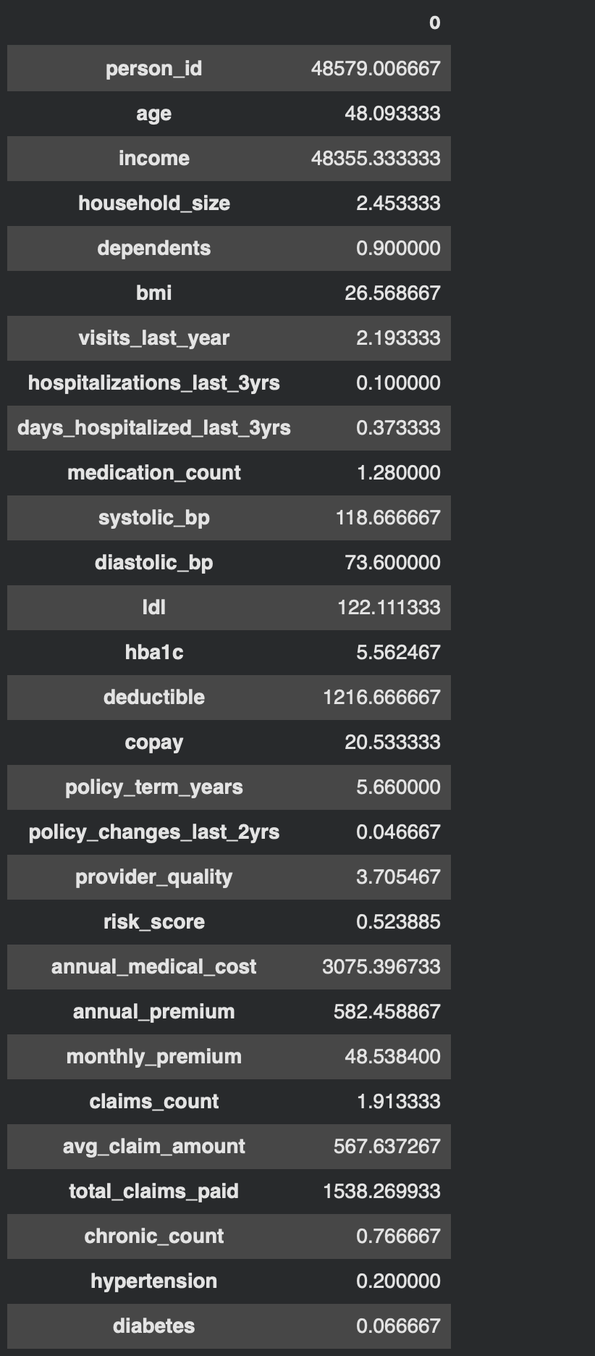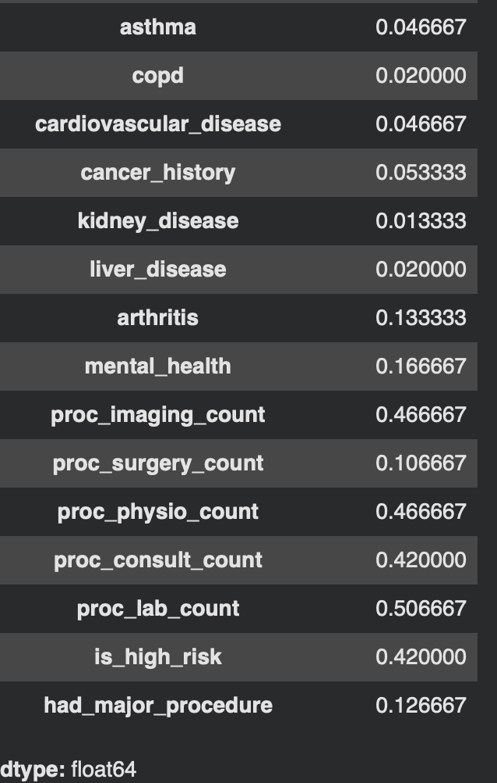

ds['annual_medical_cost'].mean()

Output:



ds.mean(axis=1, numeric_only=True)

Output:
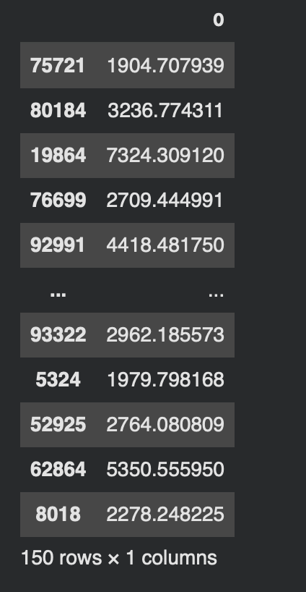

ds.median(numeric_only=True)

Output:
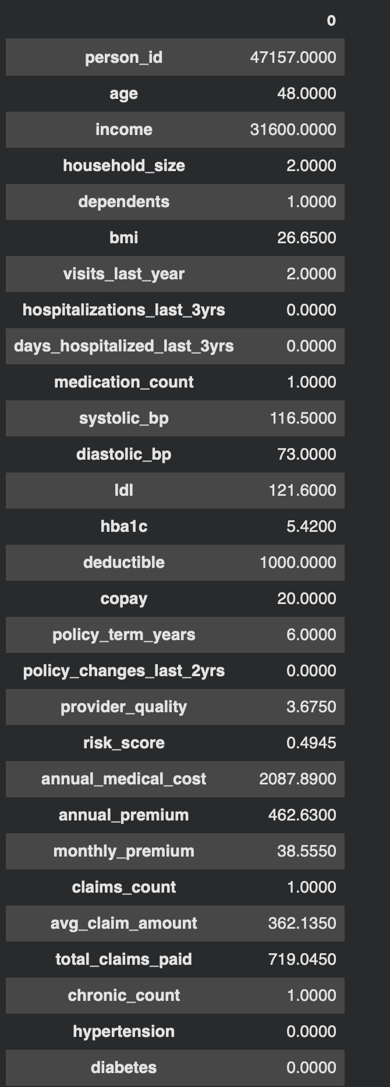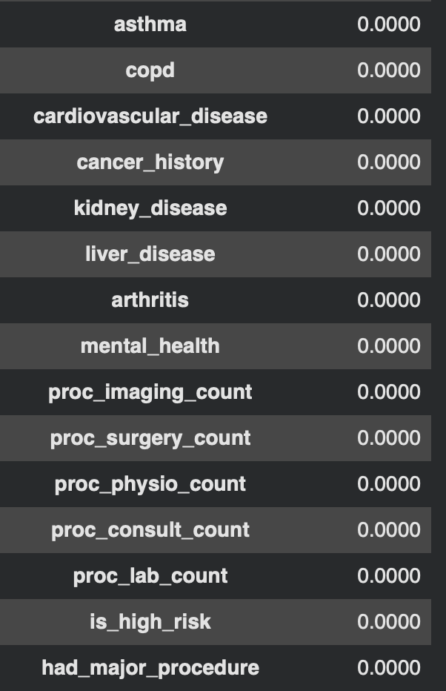

ds['annual_medical_cost'].median()

Output:



ds['region'].mode()[0]

Output:


Measure of Dispersion:

ds['annual_medical_cost'].min()

Output:



ds['annual_medical_cost'].max()

Output:



annual_medial_cost_range= ds['annual_medical_cost'].max() - ds['annual_medical_cost'].min()
print(annual_medial_cost_range)

Output:


ds['annual_medical_cost'].std()

Output:



ds['annual_medical_cost'].var()

Output:



Measure of Position:

ds['annual_medical_cost'].skew()

Output:

ds['annual_medical_cost'].kurt()

Output:

five_num = [ds['annual_medical_cost'].quantile(0),
ds['annual_medical_cost'].quantile(0.25),
ds['annual_medical_cost'].quantile(0.50),
ds['annual_medical_cost'].quantile(0.75),
ds['annual_medical_cost'].quantile(1)]
five_num

Output:
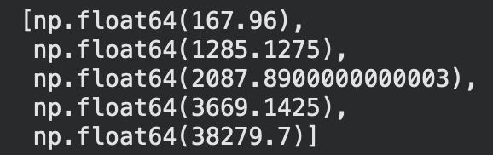
ds['annual_medical_cost'].quantile(0.75) - ds['annual_medical_cost'].quantile(0.25)

Output:



Measure of Position:

ds['person_id'].count()

Output:



ds['region'].value_counts()

Output:
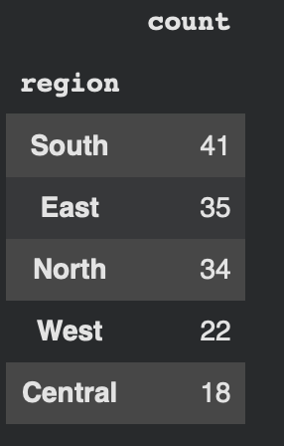

ds['region'].value_counts(normalize=True)

Output:
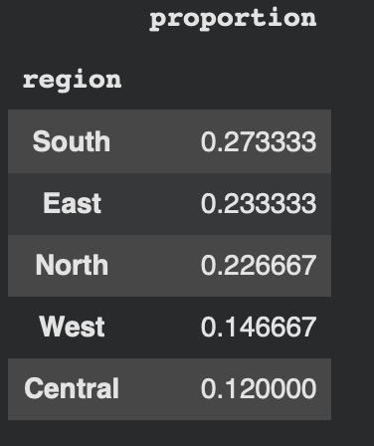

Final Descriptive Statistics:

ds.describe().T

Output:
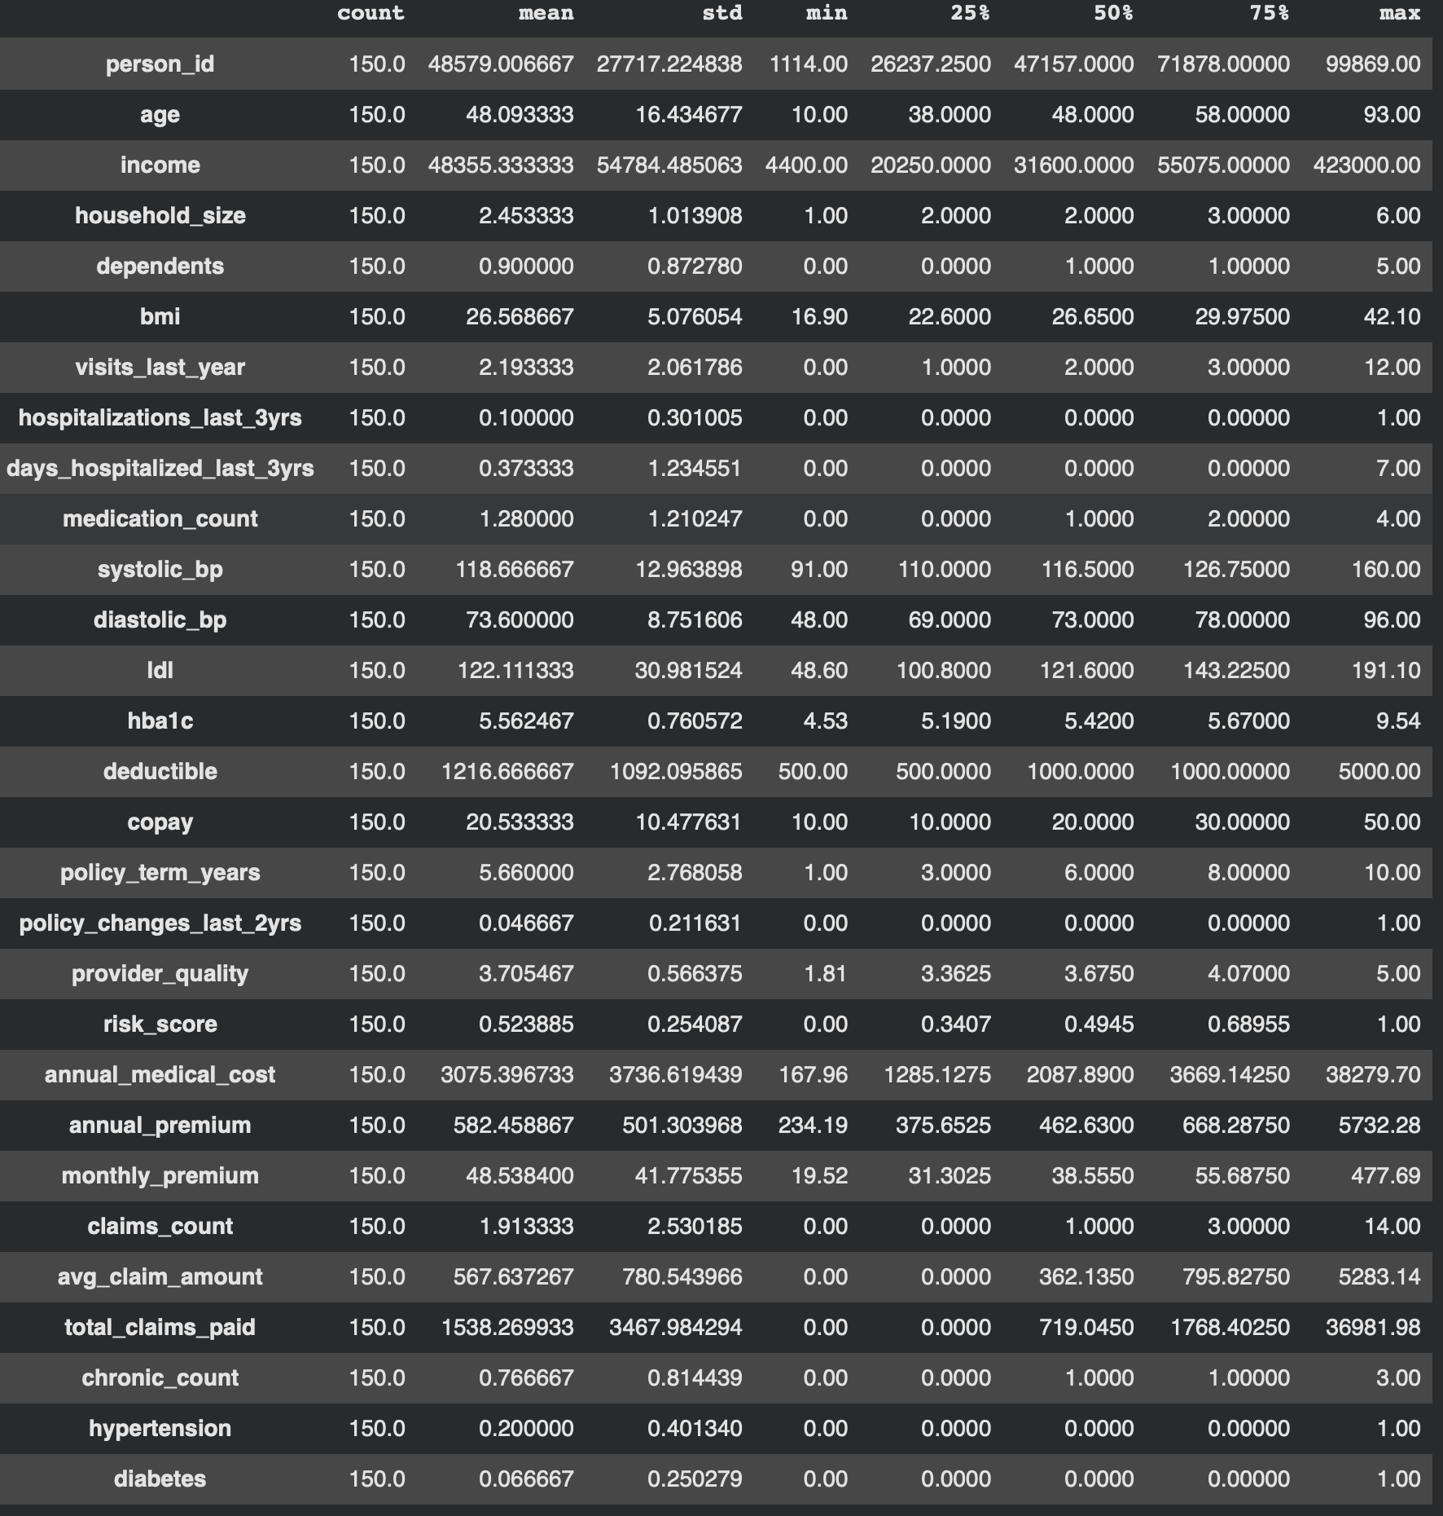
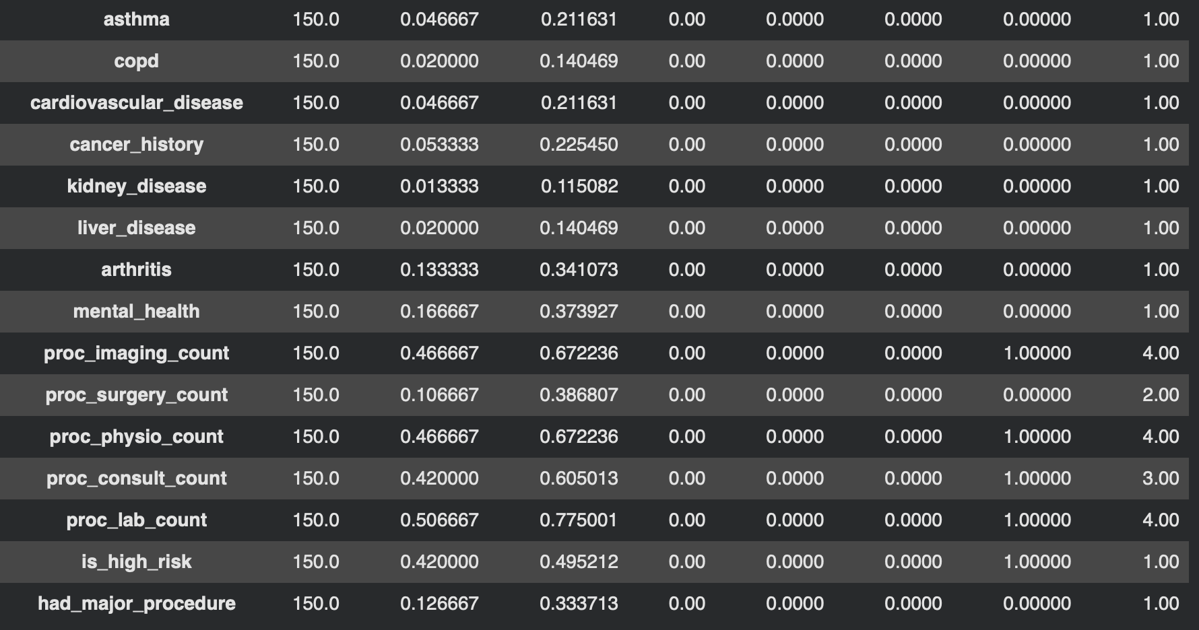

Desc_stat(ds,'annual_medical_cost')

Output:

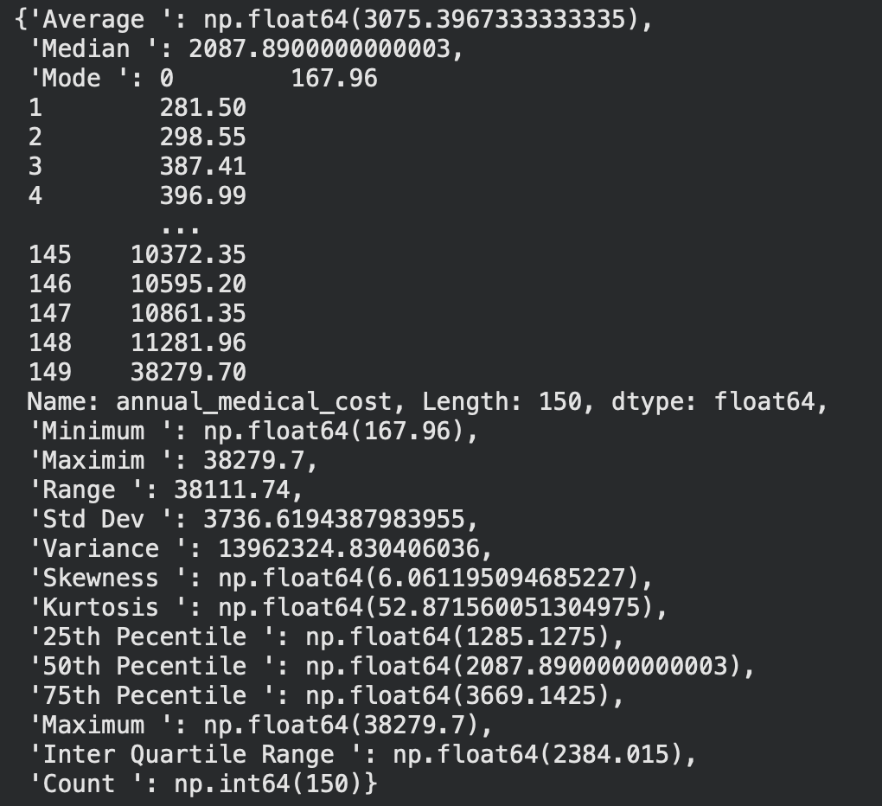

Systematic Sampling (1 point)
<< Create a script for systematic sampling by giving certain conditions and finding the desc stat for the dependent variable from the sample [Apply the descriptive function which you created]..>>

k = len(ds) // 150
print("Sampling interval (k):", k)

Output:

systematic_sample = ds.iloc[::k].head(150)

systematic_stats = descriptive_statistics(systematic_sample, "annual_medical_cost")

print(systematic_stats)

Output:

{'Count': np.int64(150), 'Mean': np.float64(3075.3967333333335), 'Median': 2087.8900000000003, 'Standard Deviation': 3736.6194387983955, 'Variance': 13962324.830406036, 'Minimum': 167.96, 'Maximum': 38279.7, 'Range': 38111.74, 'Q1': np.float64(1285.1275), 'Q3': np.float64(3669.1425)}

Descriptive Statistical Report (1 point)
<< Create a detailed descriptive statistics report about the dependent variable of the chosen dataset.>>

Dependent Variable: Annual Medical Cost:

The dependent variable chosen for this analysis was the annual_medical_cost. This shows the total yearly medical expenses from a patient. This is a continuous variable and is measured in monetary units, which makes it suitable for statistical analysis and regression modeling. The goal of this analysis is to summarize the central tendency, dispersion, and distributional aspects of the annual medical costs.

Measures of Central Tendency:

The measures of central tendency shows the annual medical cost in the sample.
- Mean: 3,075.40
- Median: 2,087.89
- Mode: There are multiple values, therefore there is no single dominant value.
These results indicate that the mean is significantly higher than the median, which means that the distribution is positively skewed. This allows us to interpret that the presence of some individuals with high medical costs causes the average to pull upwards.
Moreover, the dataset does not reveal one specific mode, which is typical for continuous numerical variables like the medical costs.

Measures of Dispersion:

The measures of dispersion show the variability in annual medical costs.
- Minimum: 167.96
- Maximum: 38,279.70
- Range: 38,111.74
- Standard Deviation: 13,962,324.83
- Interquartile Range (IQR): 2,384.02
The range of the dataset indicates a very large spread between the highest and lowest medical costs. The standard deviation is also high when compared to the mean, which shows that substantial variability does exist in the annual medical expenses. The interquartile range reveals that the middle 50% of patients have annual costs spread over an estimate of 2,384 units, which shows moderate dispersion within the central portion of the data.

Percentile Analysis:

The quartiles describe the distribution of the data:
- 25th Percentile (Q1): 1,285.13
- 50th Percentile (Q2/ Median): 2,087.89
- 75th Percentile (Q3): 3,669.14
This shows that 25% of patients spend less than 1,285.13 annually, 50% spend less than 2,087.89, and 75% spend less than 3,669.14. This indicates that most patients have moderate medical expenses, but a smaller number of patients endure very high costs.

Shape of the Distribution:

- Skewness: 6.01
- Kurtosis: 52.87
The skewness shows that the dataset has a strong positive skew, which means there are significant high cost outliers. The kurtosis value is very high, which shows that there is a leptokurtic distribution. This means that there are heavy tails, the existence of extreme outliers, and that the data is far from being normally distributed.

Overall Conclusion:

The annual medical cost variable shows the following:
- There is significant variability.
- The dataset has a strong positive skewness.
- There is the existence of significant high cost outliers.
- There is a non-normal distribution.
While most of the patients typically have moderate medical costs, a small portion of patients endure very high expenses, which causes the mean and overall variability to increase. These results are expected as typical healthcare cost data are unevenly distributed throughout the population.

Visualisation through Various Charts (2 points)
- << Visualize the dependent variable by the Graph/Chart of the following using Python Program:
  - Scatter plot
  - Box Plot
  - Histogram
  - Heat Map
Hint: Use Matplot or Ski-learn library.>>

Scatter Plot:

import pandas as pd
import matplotlib.pyplot as plt

# load the data into a pandas dataframe
df = pd.read_csv('medical_insurance.csv')

# create a scatter plot for Student ID Vs Final
df.plot.scatter(x = 'person_id', y = 'annual_medical_cost', s = 2, c = 'red')

Output:

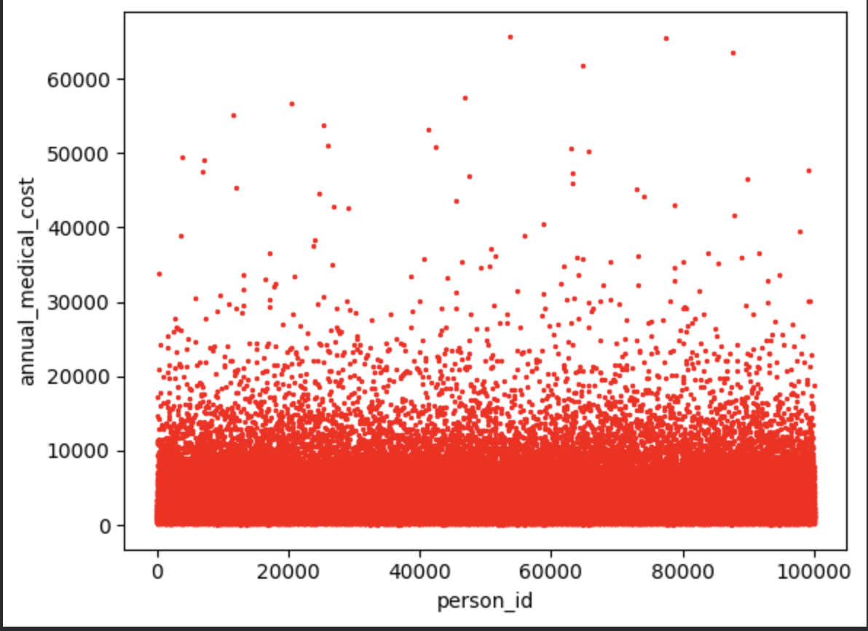

Box Plot:

import matplotlib.pyplot as plt
ds.boxplot(column='annual_medical_cost',
return_type='axes',
figsize=(8,8))

Output:

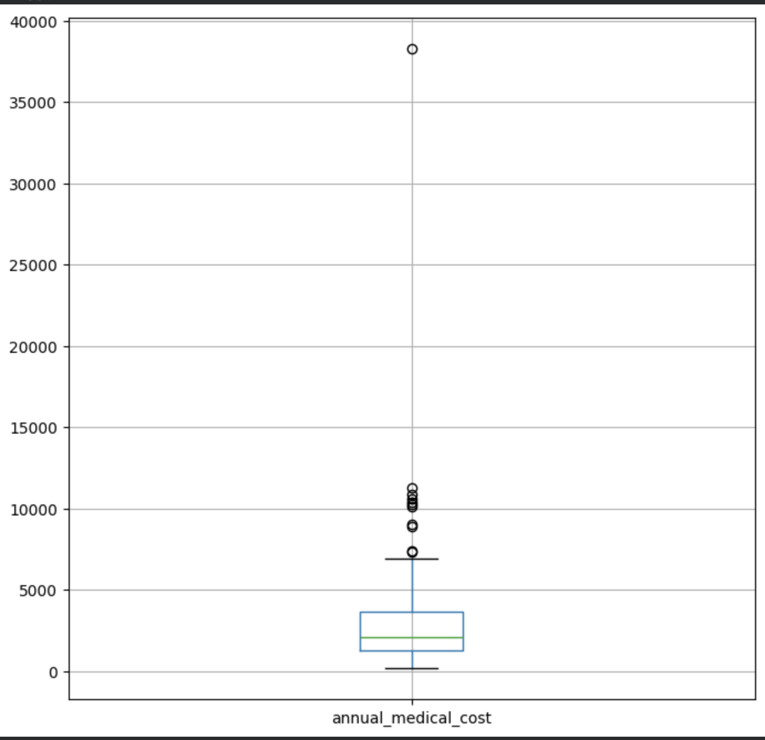

import seaborn as sns
sns.set_style('whitegrid')
ax= sns.boxplot(x='annual_medical_cost',y='region',data=ds)
ax = sns.stripplot(x='annual_medical_cost', y='region',data=ds)

Output:

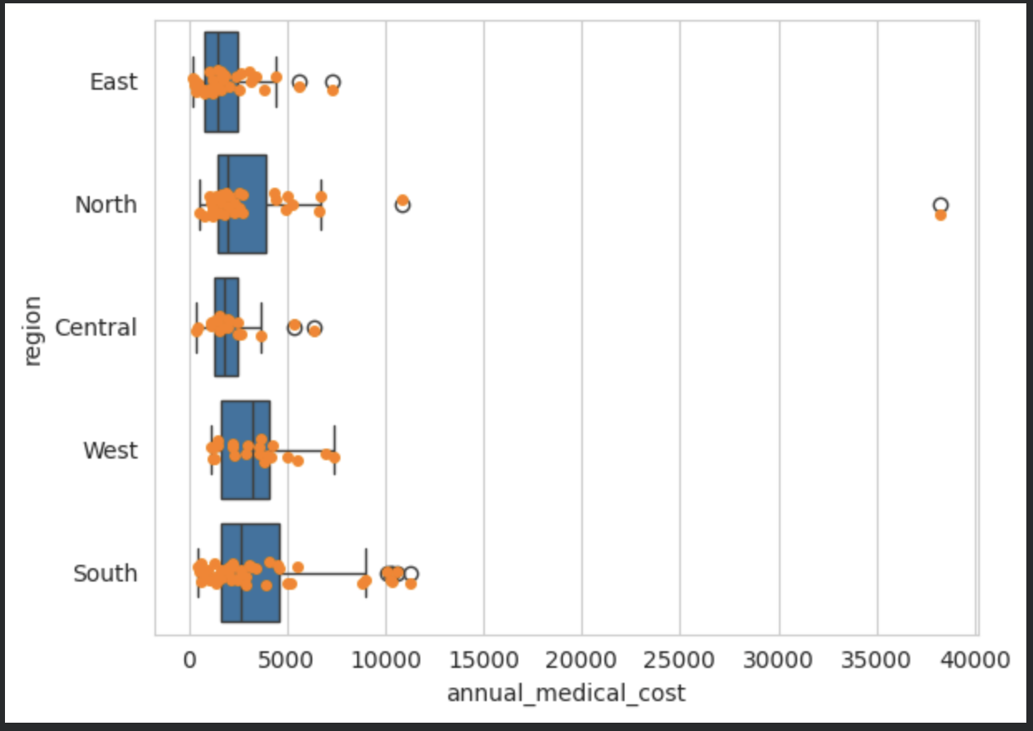

Histogram:

import pandas as pd
import matplotlib.pyplot as plt

# load the data into a pandas dataframe
df = pd.read_csv('medical_insurance.csv')

# create a histogram
plt.hist(df['income'], bins=5, edgecolor='black')

# add labels and title
plt.xlabel('annual_medical_cost')
plt.ylabel('region')
plt.title('Distribution of Medcial Costs')

# display the plot
plt.show()

Output:
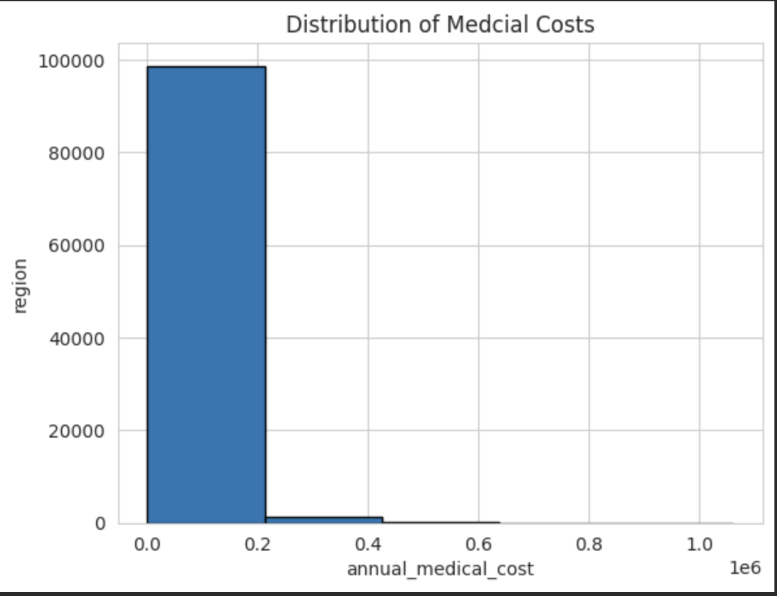

Heat Map:

import pandas as pd
import seaborn as sns
import numpy as np
import matplotlib.pyplot as plt

# create data
df = pd.read_csv('medical_insurance.csv')

# plot
pivot_table = pd.pivot_table(df, index='region', values='annual_medical_cost', aggfunc='sum')
sns.heatmap(pivot_table, cmap='Blues')

plt.ylabel('Zone')
plt.title('Total Annual Medical Cost by Zone')

plt.show()

Output:

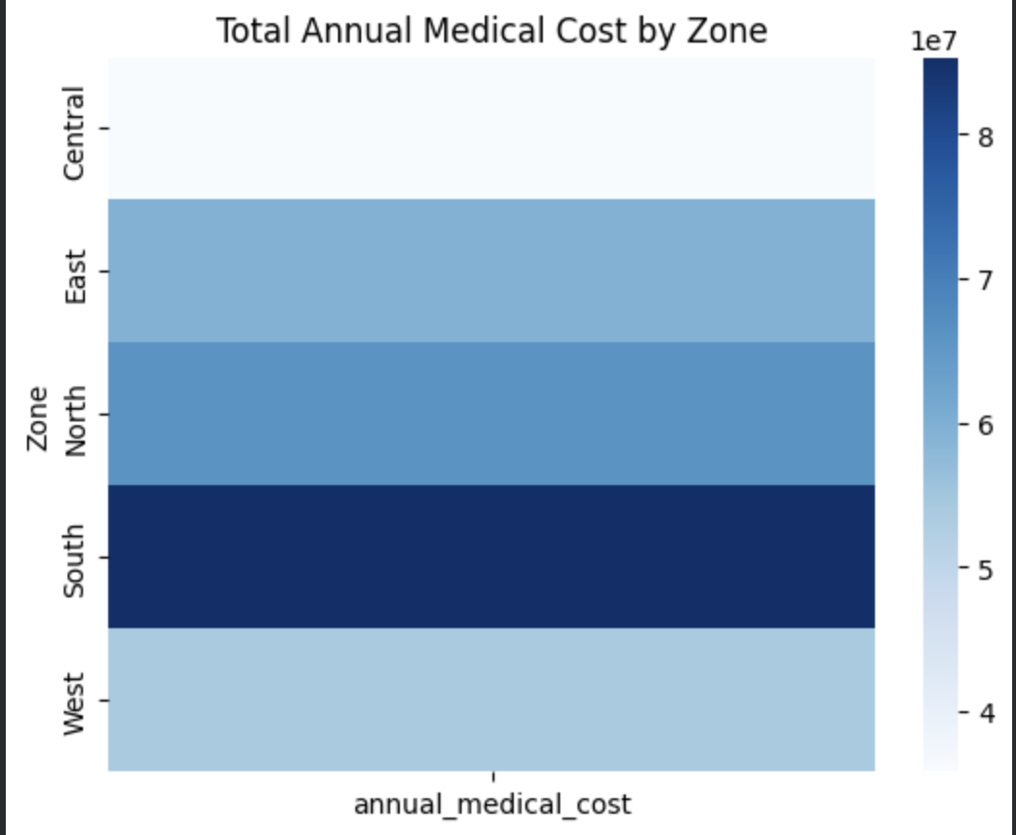

Hypothesis Test (1 point)
<< 8. Perform the hypothesis test to find the correlation (Pearson and Spearman for numerical variable and chi-square test for categorical variable) between the independent variable and the dependent variable.
Note: If you have more than one independent variable, then choose any one of the independent variables..>>

Spearman Test:

#Spearman Rank Correlation
import pandas as pd
from scipy.stats import spearmanr

# Load the dataset
file_path = 'medical_insurance.csv'
df = pd.read_csv(file_path)

# Drop rows with NaN values for Project and Final
data = df[['region', 'annual_medical_cost']].dropna()

# Perform Spearman's Correlation Test
r, p_value = spearmanr(data['region'], data['annual_medical_cost'])
df_spearman = len(data) - 2

# Print the results
print("Spearman's Correlation Test Results:")
print(f"Spearman's Correlation Coefficient (r): {r:.4f}")
print(f"P-Value: {p_value:.4f}")
print(f"Degrees of Freedom: {df_spearman}")

# Interpretation
if p_value < 0.05:
print("\nConclusion: Since the p-value is less than 0.05, we reject the null hypothesis.")
print("There is a statistically significant correlation between Region and annual medical costs.")
else:
print("\nConclusion: Since the p-value is greater than 0.05, we accept the null hypothesis.")
print("There is no statistically significant correlation between Region and annual medical costs.")

Output:

Spearman's Correlation Test Results:
Spearman's Correlation Coefficient (r): 0.0062
P-Value: 0.0495
Degrees of Freedom: 99998

Conclusion: Since the p-value is less than 0.05, we reject the null hypothesis.
There is a statistically significant correlation between Region and annual medical costs.

Pearson Test:

from scipy.stats import pearsonr
import pandas as pd

df = pd.read_csv('medical_insurance.csv')

x = df['income']
y = df['annual_medical_cost']

# Drop missing values together
data = df[['income','annual_medical_cost']].dropna()

r_value, p_value = pearsonr(data['income'], data['annual_medical_cost'])

print(f"Pearson r: {r_value:.3f}")
print(f"P-value: {p_value:.3f}")

Output:


# Extract numeric variables
income_scores = df['income']
annual_medical_cost_scores = df['annual_medical_cost']

# Drop missing values together
data = df[['income', 'annual_medical_cost']].dropna()
income_scores = data['income']
annual_medical_cost_scores = data['annual_medical_cost']

# Calculate Pearson correlation
r_value, p_value = pearsonr(income_scores, annual_medical_cost_scores)
degrees_of_freedom = len(income_scores) - 2

# Print results
print(f"Pearson Correlation Coefficient (r): {r_value:.3f}")
print(f"P-Value: {p_value:.3f}")
print(f"Degrees of Freedom: {degrees_of_freedom}")

# Interpretation
if p_value < 0.05:
print("\nConclusion: Since the p-value is less than 0.05, we reject the null hypothesis.")
print("There is a statistically significant correlation between income and annual medical costs.")
else:
print("\nConclusion: Since the p-value is greater than 0.05, we accept the null hypothesis.")
print("There is no statistically significant correlation between income and annual medical costs.")

Output:
Pearson Correlation Coefficient (r): -0.006
P-Value: 0.059
Degrees of Freedom: 99998

Conclusion: Since the p-value is greater than 0.05, we accept the null hypothesis.
There is no statistically significant correlation between income and annual medical costs.

One Sample T-test (2 points)
<< Assess the performance of the dependent variable to know whether the sample is representative of the normal population by a one-sample t-test..>>

contingency_data = pd.crosstab(df['region'], df['is_high_risk'])
print(contingency_data)

Output:
is_high_risk 0 1
region
Central 7568 4513
East 12610 7374
North 13993 8034
South 17803 10226
West 11245 6634

df = pd.read_csv("medical_insurance.csv")
annual_cost = df['annual_medical_cost']

print(annual_cost)
print(annual_cost.mean())

Output:
0 6938.06
1 1632.61
2 7661.01
3 5130.27
4 1700.73
...
99995 1295.04
99996 1451.73
99997 2291.00
99998 1279.76
99999 465.70
Name: annual_medical_cost, Length: 100000, dtype: float64
3009.4519070000006

cost_south = df[df['region'] == 'South']
cost_south['annual_medical_cost']

Output:
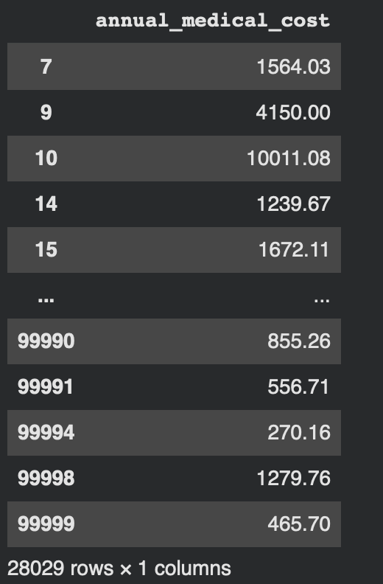

from scipy.stats import shapiro

r, p = shapiro(annual_cost)

print('r=%.2f, p=%.30f' % (r, p))

if p > 0.05:
print('Normal distribution')
else:
print('Not a normal distribution')

Output:
r=0.68, p=0.000000000000000000000000000000
Not a normal distribution
/usr/local/lib/python3.12/dist-packages/scipy/stats/_axis_nan_policy.py:579: UserWarning: scipy.stats.shapiro: For N > 5000, computed p-value may not be accurate. Current N is 100000.
res = hypotest_fun_out(*samples, **kwds)

import scipy

scipy.stats.ttest_1samp(cost_south['annual_medical_cost'], 3000)

Output:
TtestResult(statistic=np.float64(2.3113844440659), pvalue=np.float64(0.02081884605535274), df=np.int64(28028))

End of Documentation.

